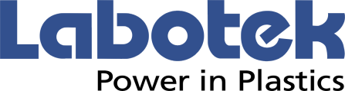
PRESS RELEASE

13th October 2023

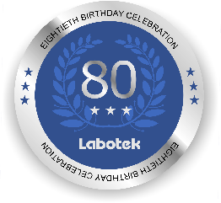
Labotek A/S celebrates its 80-year anniversary and introduces new Desiccant Dryer Mobile (DDM) 30-G
Maximum Energy Efficiency and Flexibility for Smaller Sized Drying Applications
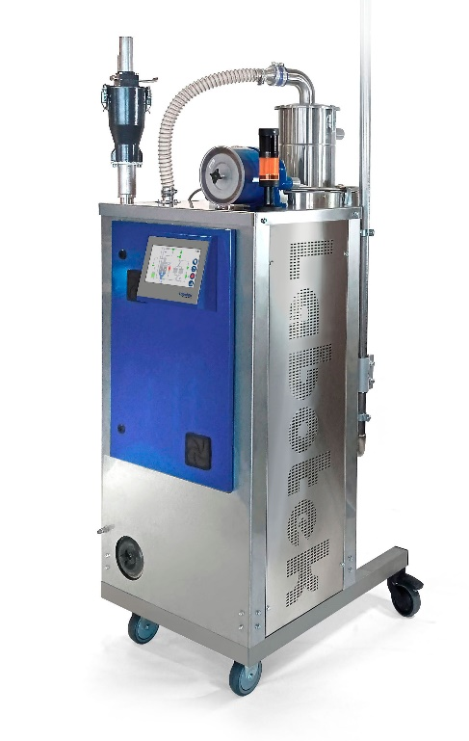

Labotek A/S today introduced a new addition to its market-leading line of ancillary equipment for the plastics industry.
The DDM 30-G Series will offer users new innovative technology that will ensure stable and uninterrupted production and significant energy savings.

Designed together with customers, for customers the DDM 30-G Series features adaptive drying technology via a built-in load cell system, “ramp up” and “ramp down” functionality, a unique dry air conveying system, plus the Labotek Energy Saving System (LESS).

With a drying hopper capacity of 30 liters and a footprint of only 0.5 m², the DDM 30-G is ideal for small applications. The all stainless steel cabinet makes it a perfect fit for medical applications too. Control is all new using a 7” touch screen with OPC UA connectivity, material database, and much more.

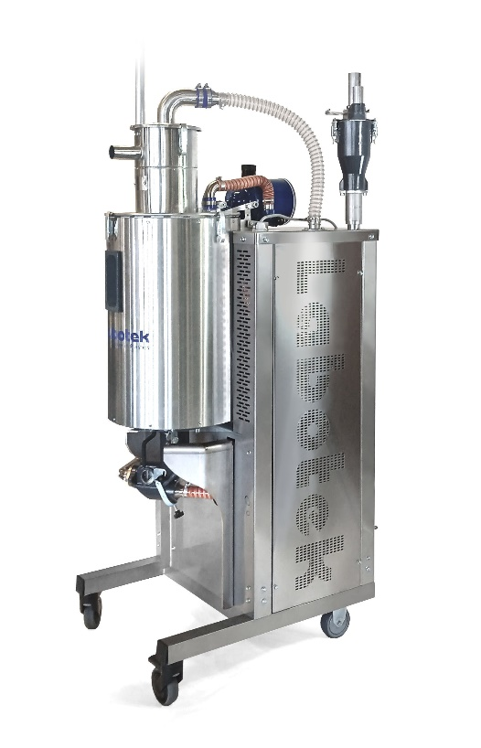

Morten Ingemann Thaysen, COO Labotek A/S:
“the new DDM 30-G is truly a unique small-footprint mobile dryer with adaptive drying technology which makes it very flexible.
With selective dew point of -40°C to -60°C and
a drying range of 60-140°C, the Labotek DDM 30-G is the best product in its class.”

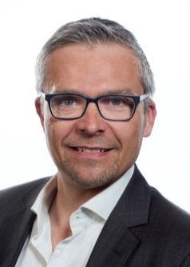
“Labotek A/S has been an innovative market leader for 80 years,” says Thomas Ringheim, CEO. “The DDM 30-G has come to life in intense partnership with customers, and has resulted in this unique compact dryer, all developed within just 12 months.”

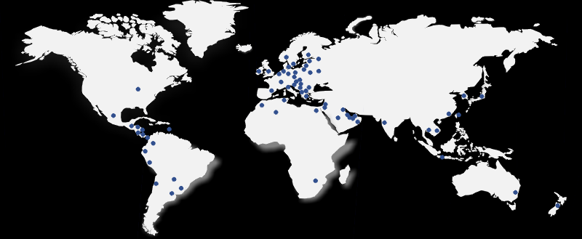

Founded in 1943, Labotek A/S has been a pioneer of high-quality, cutting-edge solutions to the plastic industry since its inception. Today Labotek A/S is a leading provider of ancillary and centralized systems, all developed using the newest technologies and designed to reduce energy consumption to the absolute minimum.
Labotek supplies equipment designed for crystallization and for drying, transport, dosage, and storage of free-flowing plastic granules and transport of free-flowing powdered materials.

The Labotek Group companies are located in Scandinavia, Germany, the United Kingdom & India. Having its R&D and Support center in Frederikssund, Denmark, production facilities in Denmark and India, and a worldwide net of subsidiaries and partners, Labotek is ready to maintain and expand its position as the industry’s preferred supplier of quality solutions.

For detailed product information, see: www.labotek.com

PARTNER

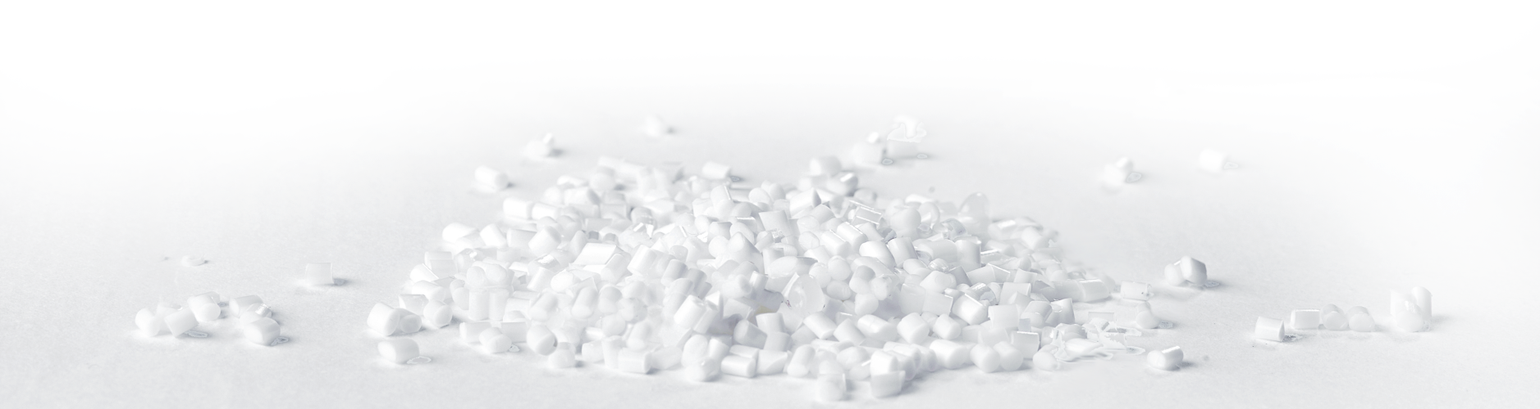
Labotek A/S
Stroebjergvej 29 · DK-3600 Frederikssund, Denmark
Tel. +45 4821 8411 | info@labotek.dk | www.labotek.com

